**Supplementary Information**

**Diverse lithic production strategies in southwest China during Late Middle Pleistocene**

**Authors:** Yue Hu1,2*, Ben Marwick3*, Hongliang Lv1, Yamei Hou4,5, Weiwen Huang4,5, Bo Li2,6

**Affiliations:**

1, School of Archaeology and Museology, Sichuan University, Chengdu 610207, China

2Centre for Archaeological Science, School of Earth and Environmental Sciences, University of Wollongong, Wollongong, NSW 2522, Australia

3Department of Anthropology, University of Washington, Seattle 98195, USA

4Key Laboratory of Vertebrate Evolution and Human Origins, Institute of Vertebrate Paleontology and Paleoanthropology, Chinese Academy of Sciences, Beijing 100044, China

5Institute of Vertebrate Paleontology and Paleoanthropology, Chinese Academy of Sciences, Beijing 100044, China

6ARC Centre of Excellence for Australian Biodiversity and Heritage, University of Wollongong, Wollongong, NSW 2522, Australia

*Correspondence to: YH (yh280@scu.edu.cn), BM (bmarwick@uw.edu).

**Keywords:** Middle Palaeolithic, Southwest China, Guanyindong, Diversity, Levallois, Quina

# Lithic technological analysis

## Raw materials

The raw materials of the assemblage are dominated by chert (77.3%) followed by limestone (21.7%) and basalt (0.9%). Other materials (such as sandstone and quartz) were only rarely used (0.4%) (**Table S1**). The dominant exploitation of chert for core reduction and tool manufacture suggests that the Guanyindong hominins deliberately selected chert as the raw material, being aware that chert is comparatively isotropic and fine-grained, allowing them to have a closer control over artefact production. The majority of raw materials are accessible within 6 km of the site (Leng 2001, Li, Hou et al. 2009). Specifically, chert is available within about 2–6 km, while limestone and volcanic rocks (such as basalt and quartz) are all available from local mountains, river bed and exposed sediments. In Middle Pleistocene, most lithic materials were obtained from nearby sources (< 5 km) or relatively close localities (5–20 km), and sources beyond 20 km are rare (Fernandes, Raynal et al. 2008). The Guanyindong tool-makers have been foraging for tool-stone over landscape ranges consistent in scope with other Middle Pleistocene population.

**Table S1 | Assemblage categories and proportion by raw materials of Guanyindong site.**

|  |  |  |  |  |  |  |  |  |  |
| --- | --- | --- | --- | --- | --- | --- | --- | --- | --- |
| **type** | **chert** | | **basalt** | | **limestone** | | **others** | | **total** |
| **count** | **%** | **count** | **%** | **count** | **%** | **count** | **%** |
| **cores** | 208 | 83.9 | 2 | 0.8 | 38 | 15.3 |  |  | 248 |
| **complete flake** | 141 | 74.6 |  |  | 46 | 24.3 | 2 | 1.1 | 189 |
| **flake breaks** | 6 | 100 |  |  |  |  |  |  | 6 |
| **debris** | 569 | 74 | 8 | 1 | 190 | 24.7 | 2 | 0.3 | 769 |
| **retouched chunks** | 43 | 76.8 |  |  | 13 | 23.2 |  |  | 56 |
| **retouched flakes and breaks** | 736 | 78 | 10 | 1.1 | 192 | 20.4 | 5 | 0.5 | 943 |
| backed knife | 5 | 71.4 |  |  | 2 | 28.6 |  |  | 7 |
| beak | 6 | 85.7 |  |  | 1 | 14.3 |  |  | 7 |
| borer | 47 | 73.4 |  |  | 17 | 26.6 |  |  | 64 |
| burin | 5 | 83.3 |  |  | 1 | 16.7 |  |  | 6 |
| chopper | 1 | 50 | 1 | 50 |  |  |  |  | 2 |
| cleaver | 1 | 100 |  |  |  |  |  |  | 1 |
| denticulate | 53 | 69.7 | 1 | 1.3 | 21 | 27.6 | 1 | 1.3 | 76 |
| End-scraper | 30 | 83.3 |  |  | 6 | 16.7 |  |  | 36 |
| natural backed | 3 | 60 |  |  | 2 | 40 |  |  | 5 |
| notch | 68 | 86.1 | 1 | 1.3 | 10 | 12.7 |  |  | 79 |
| point | 23 | 82.1 |  |  | 5 | 17.9 |  |  | 28 |
| scraper | 464 | 77.5 | 7 | 1.2 | 124 | 20.7 | 4 | 0.7 | 599 |
| tanged point | 8 | 88.9 |  |  | 1 | 11.1 |  |  | 9 |
| unidentifiable | 22 | 91.7 |  |  | 2 | 8.3 |  |  | 24 |
| **overall** | 1703 | 77 | 20 | 0.9 | 479 | 21.7 | 9 | 0.4 | 2,211 |

## Core reduction

The basic attributes of 248 cores are summarised in **Table S2** (see examples in **Figure S1**). The median maximum dimension of them is 72 mm. The median dimension is 43.5 × 55 × 47 mm (L*W*Th). The median weight of the cores is 149.5 g. Chert dominates the raw material of cores. Various geometries of cores were identified, including irregular (80.5%), conic (9.8%), column (6.7%) and small amounts of wedged and circular (~3%). Three types of cores can be identified according to the number of platforms (**Figure S2a**): single platform (60.5%), double platform (27.2%) and multiple platform (11.7%). Most pieces are ordinary cores, integrated with truncated faceted pieces (n=60; 24%), volumetric cores (n=12; 5%), discoid cores (n=10; 4%), Levallois cores (n=11; 4%), Kombewa cores (n=10; 4%), and a small number of other types (i.e. bifacial core, hemispheric core). The majority (~80%) of cores have 1–4 flake scars, and some (16%) have 5–7 scars and only a small quantity (4%) have more than 7 scars (**Figure S2b**). The distribution of length of the flake scars on cores is shown in **Figure S2c**.

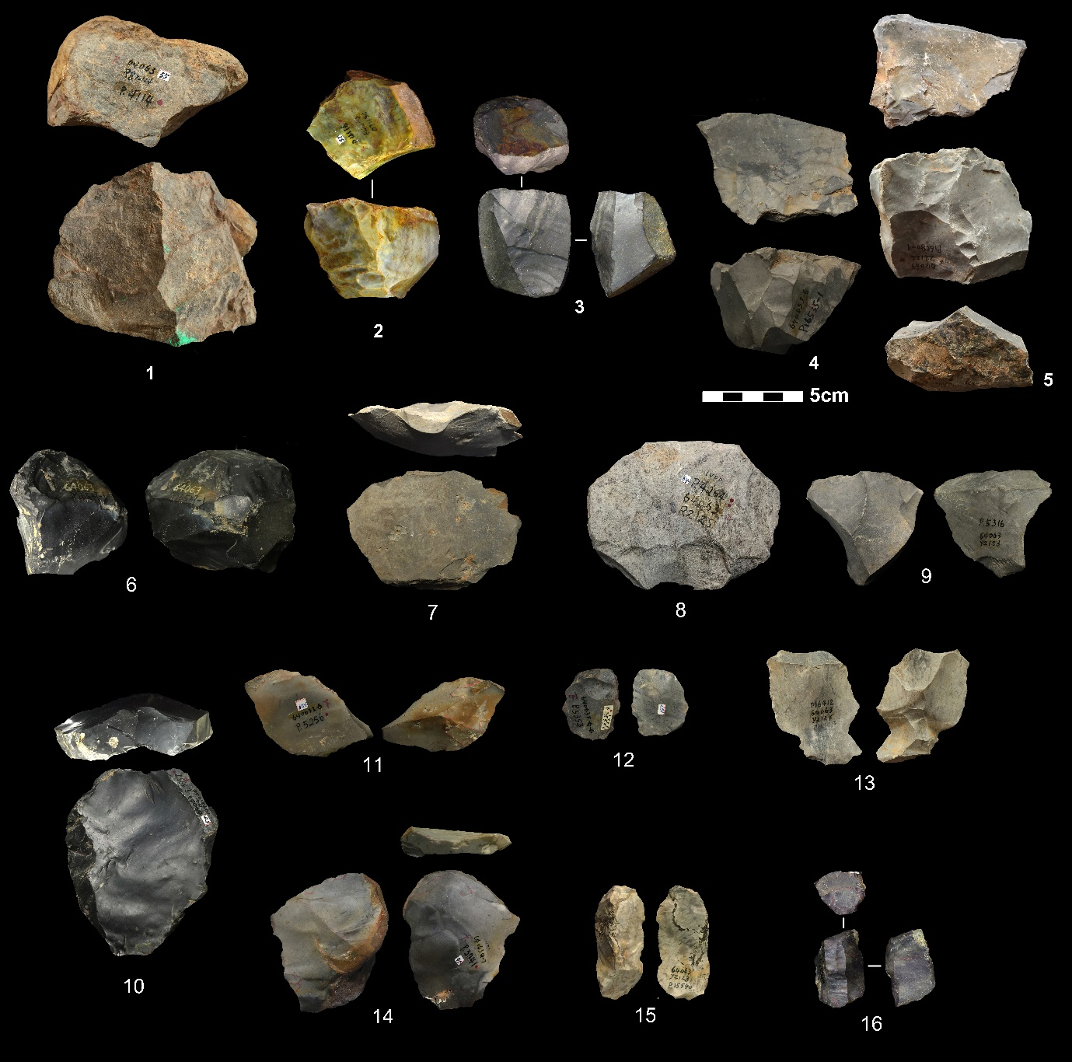

**Figure S1 | Photos showing selected cores and flakes.** 1-2, 4, single platform cores; 3,5, double platform cores; 6, discoid cores; 8, truncated faceted; 7, 9-14, flakes; 15, crest flake; 16, volumetric core.

**Table S2 | Summary of mean, standard deviation (SD), coefficient of variation (CV) for basic core attributes.**

|  | **Length (mm)** | **maximum dimension (mm)** | **medial width (mm)** | **distal width (mm)** | **thickness (mm)** | **distal thickness (mm)** | **mass (g)** | **scar number** | **cortex percentage (%)** |
| --- | --- | --- | --- | --- | --- | --- | --- | --- | --- |
| **mean** | 47.2 | 75.1 | 58.0 | 49.2 | 51.8 | 38.7 | 198.9 | 2.9 | 14.5 |  |
| **SD** | 20.2 | 21.6 | 21.2 | 21.5 | 29.6 | 17.1 | 166.8 | 2.0 | 19.4 |  |
| **CV** | 0.4 | 0.3 | 0.4 | 0.4 | 0.6 | 0.4 | 0.8 | 0.7 | 1.3 |  |

Most cores (78%) are covered with zero or a low percentage (< 25%) of cortex (**Figure S2d**). The cortex locations are always on platforms and bottoms. The majority of platform types are plain (54%), followed by facetted platforms (18.2%) (**Figure S2e**). Most cores (83%) have one or two rotations, which means that cores were rotated one to two times during flake removals to find a new platform to keep flaking when current platform and the original platform is no longer suitable for further striking. About 10% of the cores have three or more rotations.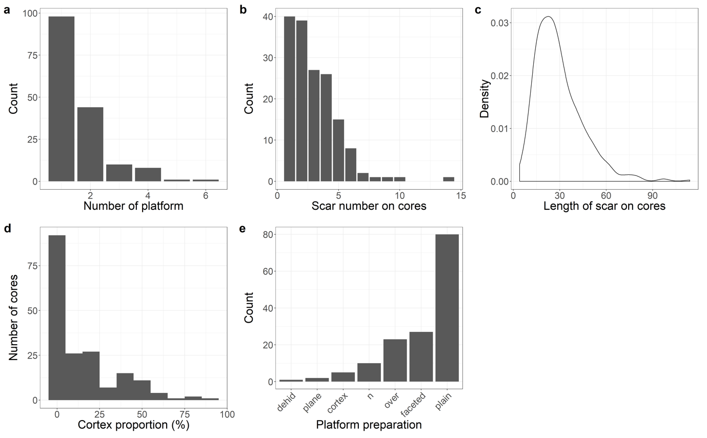

**Figure S2 | Statistical results of cores.** (a, b, d, e) Histograms showing the number of cores with different number of platforms, scar number, cortex proportion and platform types. (c) Density distribution of the scar length on cores.

Volumetric cores were manufactured on various blanks such like chunks, nodular and flake. Direct hard hammer percussion is the technique to reduce cores. The median max dimension of the cores is 52.4 mm. Most of cores do not have cortex remained and the median number of scars left is 4. The morphologies of the cores are various, including irregular, column, wedged and cubic. Plain and prepared platforms dominate the core platform types. The cores are only minimally prepared, and the volume is not thoroughly shaped out before starting the production.

Many cores were exploited from large flakes, of which four patterns are observed based on the directions of knapping, unidirectional and bidirectional (**Figure S3**). Those cores are primarily knapped along the periphery of the flake, using the natural slab morphology of a flake as platform and volumetric consumption.

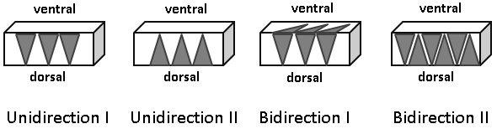

**Figure S3 | Flake core patterns.** The gray triangles indicate the directions of flake scars. Unidirection I and II means flake scars only come from one direction. Bidirection I and II means flake scars come from two different directions.

## Flakes

Among the 1,138 flake pieces studied (see **Figure S1** for selected specimens), there are 189 complete flakes, 214 retouched flakes, 6 flake breaks and 729 retouched flake breaks. The flaking technique is mainly free hand percussion with hard hammer.

**Table S3** summarises basic flake attributes. The median dimensions of complete flakes are 48 × 49 × 16 mm (L*W*Th); this is larger than that of scars remained on the cores, suggesting that many of the flakes were obtained outside of the cave, or that the cores that produced them were removed from the assemblage. The majority of flakes have masses from 10 to 100 g (**Figure S4a**) and maximum dimensions from 20 to 80 mm (**Figure S4b**). The median maximum dimension of flakes pieces is ~60 mm. The median ratios of length and oriented thickness of complete flakes is 3 and more than 86% of the ratios are greater than 2, suggesting that the flakes are relatively thin and indicating a capability of knapping control (**Figure S4c**). **Figure S4d** and **S4e** shows the thickness and width at 25%, 50% and 75% of maximum dimension, respectively. Both the thickness and width at 50 % of maximum dimension are systematically and slightly larger than those at the other parts. This also suggests a high degree of control over the morphology of flakes.

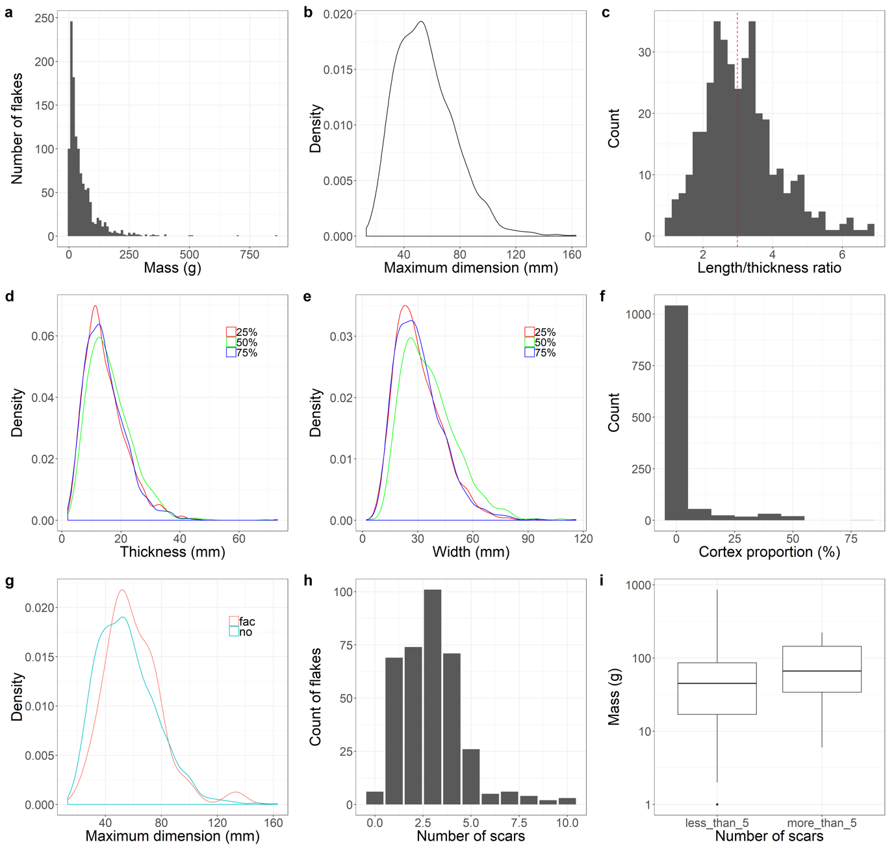

**Figure S4 | Statistical results for flakes.** (a, c, f and h) The counts of flakes for different mass, different length/thickness ratios (dotted line shows the mean value), cortex proportion and number of dorsal scars. (b, d, and e) Density distribution of flakes for different maximum dimension, thickness, and width. (g) Comparison of density distributions of flakes with (fac) and without (no) faceted platforms. (i) Box plots showing the mass difference between flakes with different scar numbers.

More than 80% of the flakes (including retouched flakes) have no cortex (**Figure S4f**). The cortex proportion of those flakes is mainly restricted from 5 to 10%. It suggests that most of flakes were introduced into the assemblage at later stages of reduction. It is likely that hominins took secondary products into the cave after they initially knapped blanks outside.

There are 396 artifacts that have distinguishable platforms, these can be divided into cortical (n=36; 9.1%), plain (n=212; 53.5 %), faceted (n=43; 10.9%), dihederal (n=45; 11.4%) and focus (n=20; 5.1%). Although the plain and cortical platforms make up the largest proportion, flakes with prepared platforms are frequently shown, indicating a predetermined strategy during core reduction. Flakes with faceted platforms are systematically larger than other platform types (**Figure S4g**), indicating that hominins prepared flake platforms as part of a strategy to produce larger flakes.

The median dorsal scar number is three (see mean value in **Table S3**) and flakes with three dorsal scars also account for the largest proportion (**Figure S4h**). Flakes with more than five scars are rare. As expected, flakes with more than five scars are systematically larger than those flakes with fewer scars, because the flake scars are fairly constant in size across the assemblage (**Figure S4i**).

The median dimension of flake platforms is 31×12 mm (W * Th, **Figure S5a**). Flake platform shapes include triangular (n=136; 44%), quadrangular (n=87; 28%), fusiform (n=46; 15%), and gull–wing (n=31; 10%) and with a small number of trapezoid, rectangle and irregular (**Figure S5b**). In order to test the possible relationships between platform shapes and flake dimension, the maximum dimension as well as thickness at 50 % of maximum dimension for different platform shapes was compared (**Figure S5c** and **S5d**). We found that flakes with gull–wing and fusiform platforms are slightly thinner (more concentrated around 10–15 mm), and those with triangular platforms are the thickest (around 20 mm). Similar patterns are observed for the maximum dimension, i.e., triangular platforms are more frequently found on larger flakes.

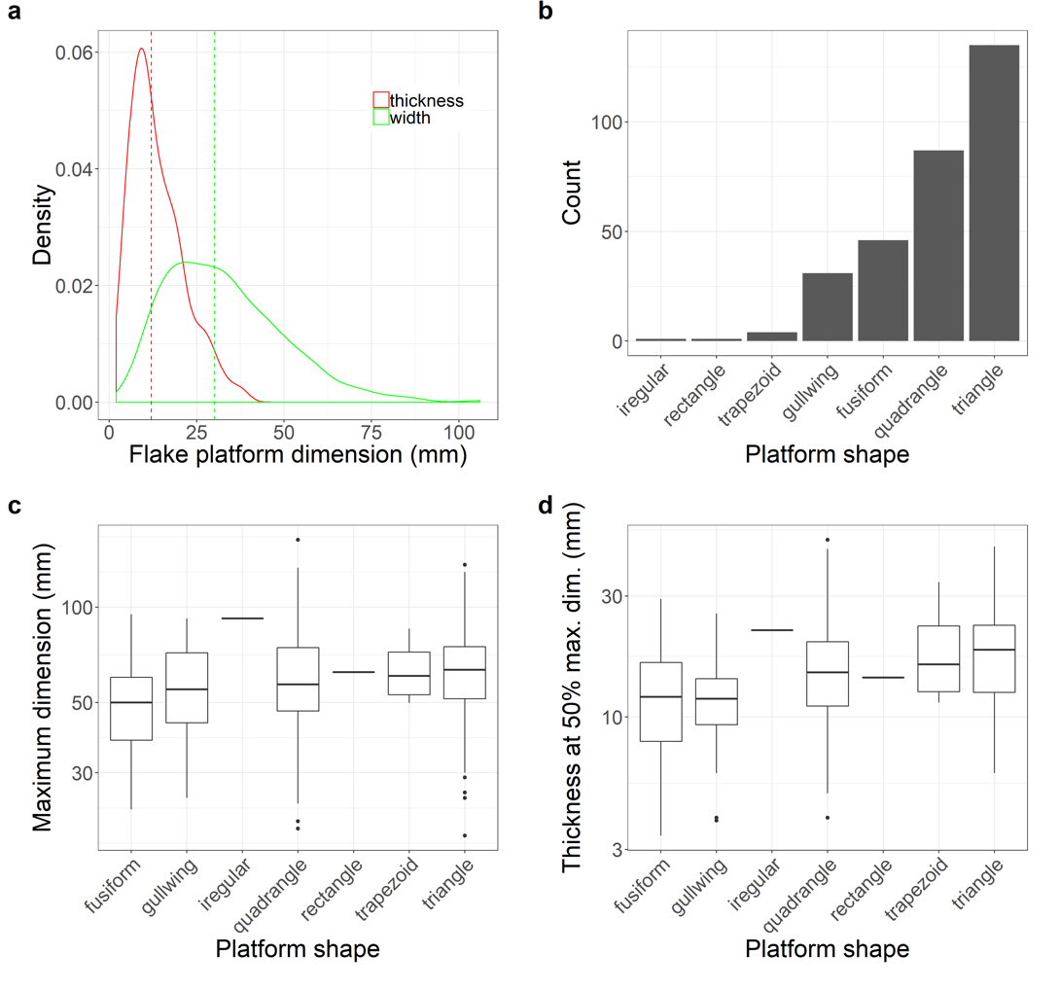

**Figure S5 | Statistical results for flake platforms.** (a) Density distribution of flakes’ platform thickness and width (dotted lines show mean values). (b) Number of flakes with different platform shapes. (c) Box plots showing the maximum dimension of flakes with different platform shapes. (d) Box plots showing thickness at 50% maximum dimension of flakes with different platform shapes.

The directions of dorsal scars from 356 flakes were recorded. We divided the directions into 8 sections (**Figure S6a**). Except for 85 scars that could not orient, the number of dorsal scars in each direction were recorded. Among them, 221 flakes have dorsal scars that have the same directions of the flake’s percussion axis. The other major directions are from directions 2, 3 and 8 (marked in the gray semi-circle) suggesting that most of the previous flakes on original cores have similar directions of the final scar. In other words, unipolar or unipolar convergent direction is the first choice when knapping a core.

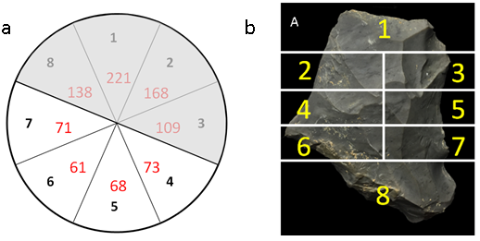

**Figure S6 | Dorsal scar directions and zone of a tool.** (a) Sketch showing the dorsal scar directions of flakes. The numbers in black are directions showing the scar directions (e.g. ‘1’ from platform; ‘3’ from right lateral; ‘5’ from distal; ‘7’ from left lateral). The numbers in red are the counts of dorsal scars that come from this direction. The gray area marks the most frequent dorsal scar directions. (b) Division of 8 sections on a tool.

Besides, 14 elongated were found including 11 elongated flakes, 3 crest flakes. The median maximum dimension of them is about 74 mm, slightly larger than volumetric cores and their platforms are mostly unprepared.

**Table S3 | Summary of mean, standard deviation (SD), coefficient of variation (CV) for basic flake attributes.**

|  |  |  |  | **length (mm)** | **maximum dimension (mm)** | **oriented width (mm)** | **width at 25% maximum dimension (mm)** | **width at 50% maximum dimension (mm)** | **width at 75% maximum dimension (mm)** | **oriented thickness (mm)** | **thickness at 25% maximum dimension (mm)** | **thickness at 50% maximum dimension (mm)** | **thickness at 75% maximum dimension (mm)** | **mass (g)** | **platform width** | **platform thickness (mm)** | **scar number** | **cortex percentage (%)** |
| --- | --- | --- | --- | --- | --- | --- | --- | --- | --- | --- | --- | --- | --- | --- | --- | --- | --- | --- |
|  |  |  | **mean** | 49.4 | 62.5 | 50.3 | 36.3 | 41.9 | 35.2 | 17.6 | 16.1 | 16.6 | 13.7 | 68.2 | 32.8 | 13.7 | 2.9 | 9.4 |  |
|  |  |  | **SD** | 19.2 | 22.5 | 19.2 | 14.1 | 15.3 | 14.8 | 8.1 | 7.6 | 7.8 | 6.8 | 81.7 | 16.8 | 7.8 | 1.6 | 15.1 |  |
|  |  |  | **CV** | 0.4 | 0.4 | 0.4 | 0.4 | 0.4 | 0.4 | 0.5 | 0.5 | 0.5 | 0.5 | 1.2 | 0.5 | 0.6 | 0.6 | 1.6 |  |

## Retouch technologies

A total of 999 retouched pieces were found in the assemblage, accounting to 45% of lithic assemblage (see examples from **Figure S7**). The median maximum dimension is 54.1 mm. The max dimensions and masses of retouched flake are generally smaller than unretouched flakes, suggesting that they probably come from the same reduction sequence (**Figure S8a**).

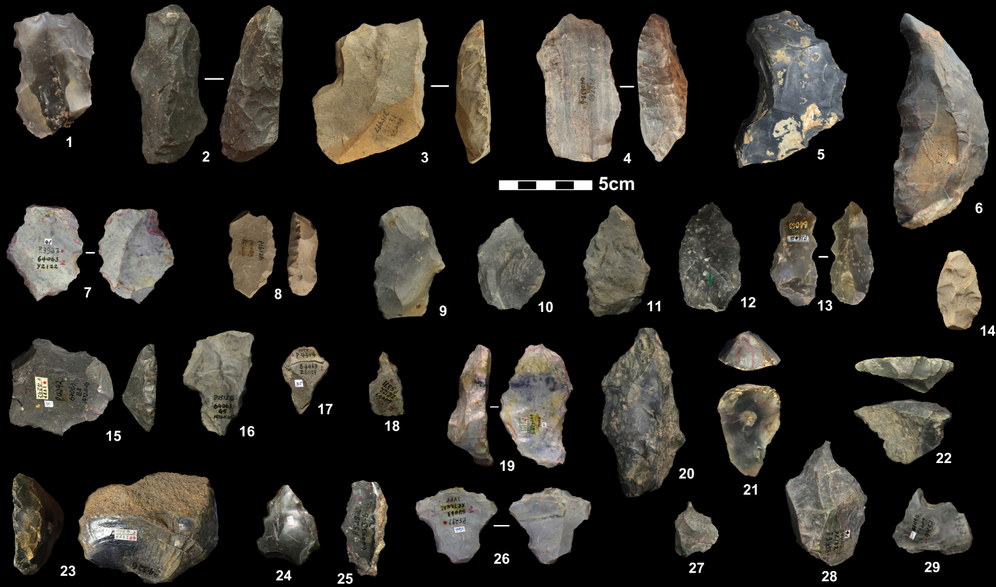

**Figure S7 | Selected retouched pieces.** 1, 7, 9, 13 and 26, denticulates; 2-6, 8, 10-12, 14, 15 and 19, scrapers; 16, notch; 17 and 24, point; 18, 27-29, borers; 20, 25, natural backed knives; 21, 23 end scrapers; 22, transverse scrapers;

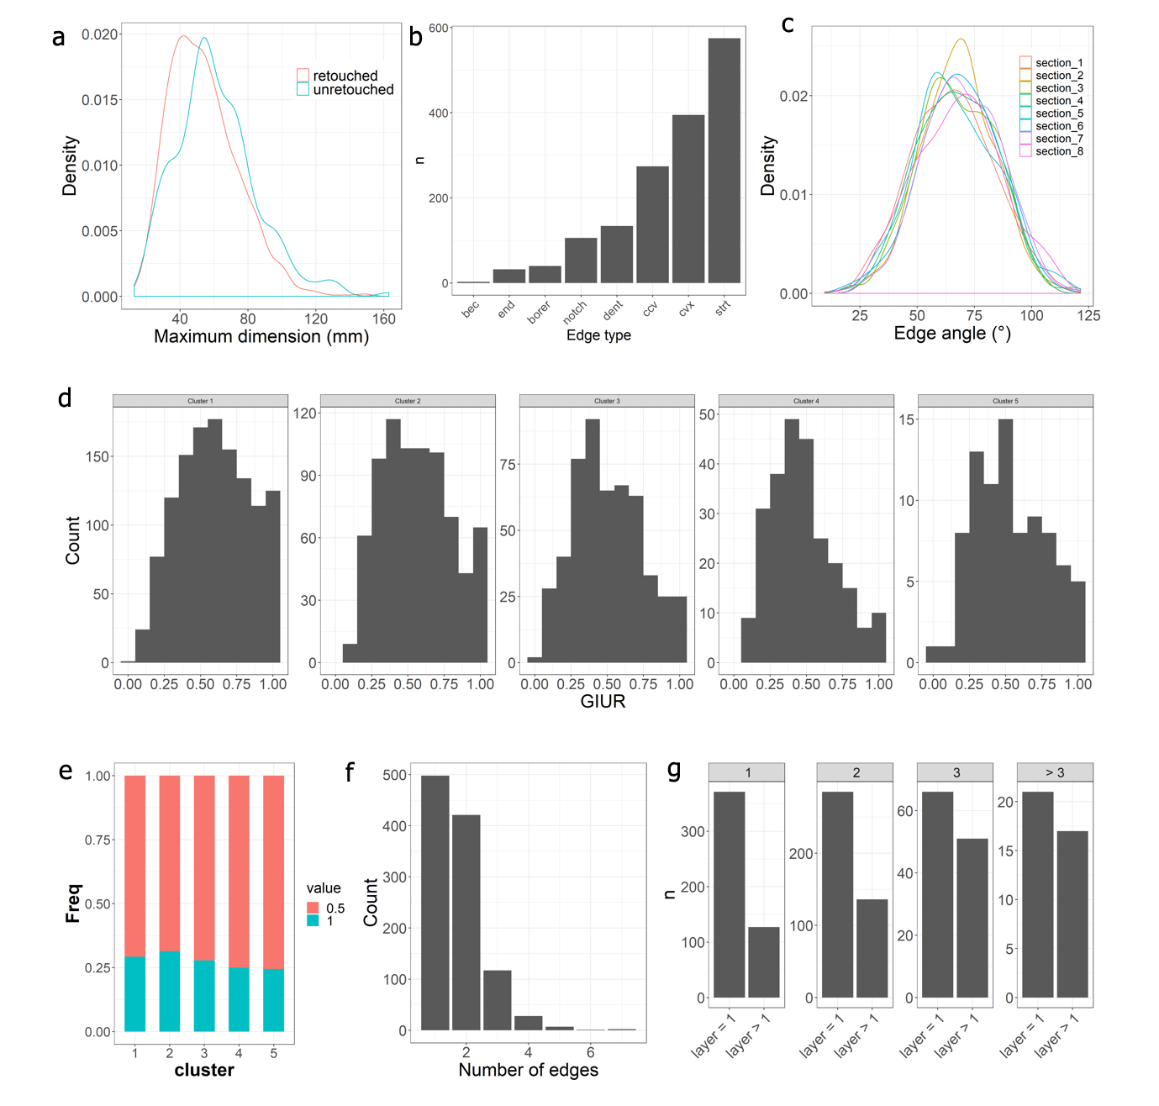

**Figure S8 | Statistical results for flake platforms.** (a) Comparison of the density distribution of the maximum dimension between retouched and unretouched flakes. (b) Histogram showing the counts of tools for different edge types. (c) Comparison of edge angles among different sections. (d) Comparison of distribution of GIUR among 5 groups of flakes with different masses. (e) Invasiveness Index if the 5 mass groups of flakes. (f) Histogram showing the counts of tools of different number of edges. (g) The counts of tools that have one and more than one retouching layers for tool with different edge number (1,2,3 and >3).

Most retouched pieces are made on flakes breaks (~70%) and complete flakes (~20%), a small number of them are made on either chunks or pebbles. Side scrapers and denticulates dominate retouched pieces (65%), followed by borers (6%) and other types (**Table S1**).

The locations and shapes of retouch and the properties of the retouching scars provide further insight into tool manufacturing and management. Among the 1,559 retouched edges that recorded (**Figure S8b**), straight edges constitute the largest proportion (n=575) followed by convex (n=395) and concave edges (n=248). We calculated the edge angles on eight sections from a tool using the method in Eren and Lycett (Eren and Lycett 2016) (see **Figure S6b**).

In **Figure S8c** we see that the angles of sections 1 to 8 are similar, mainly between 50° and 80°. The median angle of all edges is 67°. This suggests that the edge angles of the entire blank were indiscriminately retouched, and relatively steeply. More than half of all retouched pieces were retouched on two or more edges. Those data suggest extensive exploitation of blanks, probably resulting from repeated episodes of recycling and resharpening. The retouch pattern show a degree of skilled techniques. A number of retouched flakes also exhibit parallel or sub parallel retouch scars and fine retouched tools are repeatedly shown (see examples in **Figure S7**), though high standardized tools such like mousterian points are missing.

We used two indices, the index of invasiveness (Clarkson 2002) and the Geometric Index of Unifacial Reduction (GIUR) (Kuhn 1990, Hiscock and Clarkson 2005, Hiscock and Tabrett 2010) to estimate the intensity of retouch. Most specimens were extensively retouched, i.e., more than 67% have a GIUR value greater than 0.9. In order to investigate whether smaller pieces were more intensively retouched than larger pieces, we divided the flakes into five clusters of sizes based on a dynamic programming algorithm for optimal one-dimensional k-means clustering, which selects optimal number of clusters of flake sizes based on the Gaussian mixture model using the Bayesian information criterion (BIC) (see Hu et al. 2019 for details). **Figure S8d** and **S8e** shows the GIUR and Index of Invasiveness distributions according to different size groups. It shows that the smaller tools tend to have higher GIUR values (**Figure S8d**). This is consistent with our prediction that small artefact sizes are a result of more extensive retouch and reuse. For the Index of Invasiveness, about 75% of retouching scars did not pass half depth of each zone (**Figure S8e**). This is expectable since the edges of most artefacts are too steep to allow the retouching scar to extend beyond half the depth of the zone. Over half of tools have more than one retouched edge (**Figure S8f**; the edges are separated by an unretouched gap between each single retouch section). And as the number increased, the number of edges that have more than one retouched layer increases (**Figure S8g**). They suggest that the tools are heavily recycled and the Guanyindong knappers were not only inclined to resharpen the edges with secondary retouch at the same location, but also attempted to create new edges when reusing their tools.

For notched (n=79) pieces (see example in Figure S7), the median depth and length is 3.7 and 11.6mm. The majority of notch is Clactonian notches (65%). Ordinary notches only account for 32%. The rest of notches contain both Clactonian and ordinary notches. The location of retouching is mainly on one side which defined as longer geometric side of the piece.

# Controversy of Levallois concept

The utilization of Levallois concept in Guanyindong has caused many attentions since the publication (Hu, Marwick et al. 2019, Hu, Marwick et al. 2019, Li, Li et al. 2019, Li, Boëda et al. 2019, Li, Li et al. 2020). Courteous comments raised in many perspectives. To sum up, principal refutations are that there is no usage of Levallois concept in Guanyindong, Hu, Marwick et al. (2019) misread all of them, and methods Hu et al. applied is either ‘highly subjective’ or ‘morphological’. For sustaining these assertions, 1-2 cores and isolated flakes were brought up, to argue that Hu et al. interpreted the assemblage by using ‘wrong’ approach.

Here, we are not intending to go further with the general lithic analytic approaches they assume Hu et al. use, since on the ground of authentication of some pieces, it is too optimistic to come to this issue. Just to be specific, these criticisms mainly strength on verification of the following ‘misreadings’, including the platforms were not prepared; they were geologically worn; they are ‘opportunistic’, the core is actually a flake; the convexities are not prepared; cores are ‘addictive’ rather than ‘integrative’; the percussion location is ‘skew’, they are all ‘morphological’, and so on.

To avoid repeating the previous reply, here we would like to reiterate our standpoint briefly. Firstly, they are not correct that the structure of cores at Guanyindong is opportunistic and simple. Because based on our observation and analysis, both the Levallois cores and other blank production cores demonstrate a complex plan of knapping. The kind of opportunistic processes stated in their comments cannot casually or accidently produce a Levallois core that requires so many reduction steps and the complicated structure we report in our paper. Second, we are fully aware that the geological process does affected some artifacts in the assemblage (see taphonomy analysis in SI of Hu, Marwick et al. 2019), but all the Levallois products including cores and flakes had hardly been so seriously worn by post-deposit that the whole Levallois ‘complex’ pattern were vanished. In contrast, scars, no matter preferential, convexity maintaining, or platform faceting, all indicate considered removals. Third, every single core was inspected by following the wide accepted approaches developed by Boëda (1995), and those attributes were not determined accorded exclusively on its morphologies, but including the percussion angle, direction, scar pattern and chronological order, lateral and distal convexities, the configuration of the overall volume. However, part of the problem here is the use of the six criteria as a checklist rather than a guide. Boëda (1986) himself follows the checklist approach and defines cores as non-Levallois when one criterion is absent. However, in more recent research, we see a move away from this checklist system and instead the adoption of a more holistic approach, using the criteria as a guide (Scott 2006, White, Ashton et al. 2011, Bolton 2015). Thus, we see that it is normal to view the natural shape of the block as a relevant consideration when identifying the presence or absence of Levallois concepts. Were these artifacts found in, say, Late Pleistocene contexts in Africa or western Eurasia, we are confident that no-one would question their Levallois attribution. A particularly problematic detail in establishing the limits of the definition of Levallois across different core morphologies is the means by which the hierarchical relationship between the two core surfaces was established and how the platform was prepared to orient it perpendicular to the axis of flaking. Brantingham and Kuhn (2001) have previously noted that the previously published definition (Boëda 1995) gives little guidance on this. Several studies identify cores with a morphology of naturally asymmetric surfaces as Levallois, even though they lack the extensive flake removal to shape the core in preparation for the main flake removals (Delagnes 1995, Kuhn 1995, Chazan 1997, Picin 2018). Indeed, Boëda and Pelegrin (1979) have previously noted the importance of the shape of the initial form as part of the Levallois concept. For these less obvious preparation elements (for some pieces), we confirmed with the ‘holistic methods’ extracted from published and accepted approaches by other scholars exemplified above, otherwise, this core would be disqualified.

We agree that the Levallois concept describes a process, but what archaeologists are usually stuck with are items that were made at various points throughout that process. The shapes of stone cores and flakes at discard (when they enter the archaeological record) can be poor indicators of what happened throughout the life of the artefact. We admire the demonstrations from the Israeli site of Boker Tachtit, where large refit clusters enabled the reconstruction of a nearly-complete sequence of reduction. This shows well the difficulties of recognizing Levallois technology from cores or flakes without a rich refit structure. Unfortunately, such refits have not been possible at Guanyindong because of the way the assemblage has been curated since its initial excavation several decades ago. Therefore, the identification of Levallois flakes are mainly based on the technological attributes that shows the previous preparations and flaking angle. Despite the lack of refitting data, lateral and distal control of the Levallois pieces in the Guanyindong assemblage is evident from the presence of negative flake scars that have contributed to the distinctive convexities of these surfaces. Our description of P15948 is typical for this assemblage. Our reading of this piece reveals that, through faceting along the edge, the striking platform size and shape was adjusted to allow removal of flakes parallel to the plane of intersection of the upper and lower surfaces. Then, convexities were shaped and maintained with removals based on the previously prepared striking platform. We consider the success of the oriented products need coordination of steps that involving the specimen as a whole. This evidence of control represents a typical example of the Levallois pieces in the Guanyindong assemblage.

Therefore, we fail to see the point of their challenges to Hu, Marwick et al. (2019) descriptions here since their assumptions are mostly groundless. Nevertheless, we are not dedicated to it, and our points would switch if adequate evidence that supports their allegations more strongly. Indeed, the industries that displaying Levallois concept or Levallois trace more infrequent in East Asia. Other than the consequence of demography or environment that mentioned before, other reasons perhaps come from the fact that the Sites/Locations that securely dated within the MP period are few or the number of stone artifacts from some of them are very limited. Furthermore, most of them were excavated and studied decades ago during which period the bearing layers were not precisely located, and the new lithic analytic approaches have not been developed yet in China. Therefore, we believe the disputation would still last for a while, till more new found sites with safe chronological range within MP and objective re-examinations on past specimens would shed lights on this issue.

# Data collection method

Data were recorded in Excel spreadsheets. Statistical analysis, interaction patterns among categories and attributes, tables and charts were compited computed using R and RStudio. The R code used to produce the statistics and graphs presented in this thesis are openly available online at **Error! Hyperlink reference not valid.**

# References

Boëda, E. (1986). Approche technologique du concept Levallois et évaluation de son champ d’application: étude de trois gisement saaliens et weichseliens de la France septentrionale. PhD thesis, Universite de Paris X

Boëda, E. (1995). Levallois: A volumetric construction, methods, a technique. The Definition and Interpretation of Levallois Technology. H. Dibble and O. Bar-Yosef. Madison, Prehistory Press**:** 41–68.

Boëda, E. and J. Pelegrin (1979). "Approche technologique du nucleus levallois a éclat." Etudes Préhistoriques Lyon **15**: 41-48.

Bolton, L. (2015). Assessing the Origins of Levallois through Lower Palaeolithic Core Variation: A Comparative Study of Simple Prepared Cores in Northwest Europe. PhD Thesis, University of Southampton.

Brantingham, P. J. and S. L. Kuhn (2001). "Constraints on levallois core technology: A mathematical model." Journal of Archaeological Science **28**(7): 747-761.

Chazan, M. (1997). "Redefining Levallois." Journal of Human Evolution **33**(6): 719-735.

Clarkson, C. (2002). "An Index of Invasiveness for the Measurement of Unifacial and Bifacial Retouch: A Theoretical, Experimental and Archaeological Verification." Journal of Archaeological Science **29**(1): 65-75.

Delagnes, A. (1995). Variability within uniformity: Three levels of variability within the Levallois system. The Definition and Interpretation of Levallois Technology. H. L. Dibble and O. Bar-Yosef. Madison, Prehistory Press**:** 201-211.

Eren, M. I. and S. J. Lycett (2016). "A Statistical Examination of Flake Edge Angles Produced During Experimental Lineal Levallois Reductions and Consideration of Their Functional Implications." Journal of Archaeological Method and Theory **23**(1): 379-398.

Fernandes, P., J.-P. Raynal and M.-H. Moncel (2008). Middle Palaeolithic Raw Material Gathering Territories and Human Mobility in the Southern Massif central, France: First results from a petro-archaeological study on flint.

Hiscock, P. and C. Clarkson (2005). "Experimental evaluation of Kuhn's geometric index of reduction and the flat-flake problem." Journal of Archaeological Science **32**(7): 1015-1022.

Hiscock, P. and A. Tabrett (2010). "Generalization, inference and the quantification of lithic reduction." World Archaeology **42**(4): 545-561.

Hu, Y., B. Marwick, J.-F. Zhang, X. Rui, Y.-M. Hou, W.-R. Chen, W.-W. Huang and B. Li (2019). "Robust technological readings identify integrated structures typical of the Levallois concept in Guanyindong Cave, south China." National Science Review **6**(6): 1096-1099.

Hu, Y., B. Marwick, J.-F. Zhang, X. Rui, Y.-M. Hou, J.-P. Yue, W.-R. Chen, W.-W. Huang and B. Li (2019). "Late Middle Pleistocene Levallois stone-tool technology in southwest China." Nature **565**(7737): 82-85.

Kuhn, S. L. (1990). "A geometric index of reduction for unifacial stone tools." Journal of Archaeological Science **17**(5): 581-593.

Kuhn, S. L. (1995). Mousterian Lithic Technology. Princeton, Princeton University Press.

Leng, J. (2001). Early Paleolithic technology in Eastern and Southern Asia / Jian Leng. Oxford :, J. and E. Hedges : Archaeopress.

Li, F., Y. Li and X. Gao (2020). "Re-examination of core reduction strategies of the Guanyindong lithic assemblage in Guizhou." Acta Anthropologica Sinica **39**(1): 1-11.

Li, F., Y. Li, X. Gao, S. L Kuhn, E. Boëda and J. W Olsen (2019). "A refutation of reported Levallois technology from Guanyindong Cave in south China." National Science Review **6**(6): 1094-1096.

Li, Y., E. Boëda, H. Forestier and Y. Zhou (2019). "Lithic Technology, typology and cross-regional comparison of Pleistocene lithic industries: Comment on the earliest evidence of Levallois in East Asia." L'Anthropologie **123**(4): 769-781.

Li, Y. H., Y. M. Hou and E. Boëda (2009). "Mode of débitage and technical cognition of hominids at the Guanyindong site." Chinese Science Bulletin **54**(21): 3864-3871.

Picin, A. (2018). "Technological adaptation and the emergence of Levallois in Central Europe: new insight from the Markkleeberg and Zwochau open-air sites in Germany." Journal of Quaternary Science **33**(3): 300-312.

Scott, R. (2006). The Early Middle Palaeolithic of Britain; origins, technology and landscape. PhD thesis, Durham University.

White, M., N. Ashton and B. Scott (2011). 5 - The Emergence, Diversity and Significance of Mode 3 (Prepared Core) Technologies. Developments in Quaternary Sciences. N. Ashton, S. G. Lewis and C. Stringer, Elsevier. **14:** 53-65.